This submission template is a convenient document for you to provide the screenshots and explanations for Lab 2, and is intended to be used in conjunction with the Lab 2 Instructions document. The instructions document illustrates how to correctly execute each SQL construct, explains important theoretical and practical details, and contains the complete set of instructions on how to complete this lab.

**Name**: Scott Kaeneman

**Date: 5/15/2018**

Note: Section One in the lab instructions is for your benefit, to teach you by example how to complete the exercises in Section Two. It is not necessary, however, to submit the screenshots for Section One.

**SECTION TWO**

2. Table creation commands

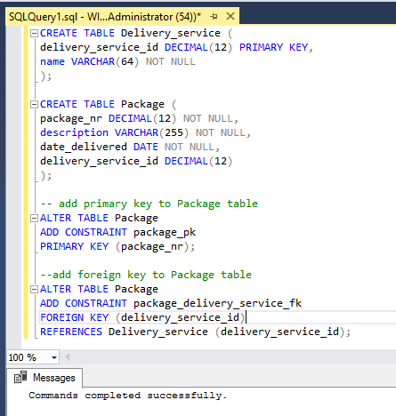

4. INSERT commands

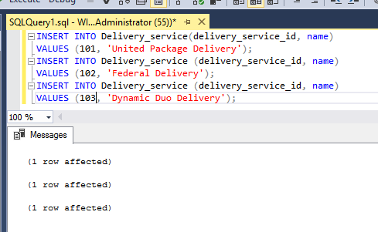

6. INSERT commands

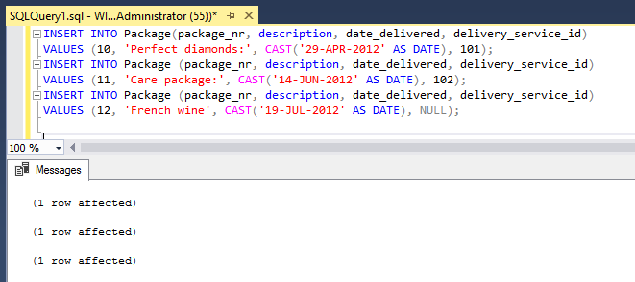

8. Invalid INSERT command

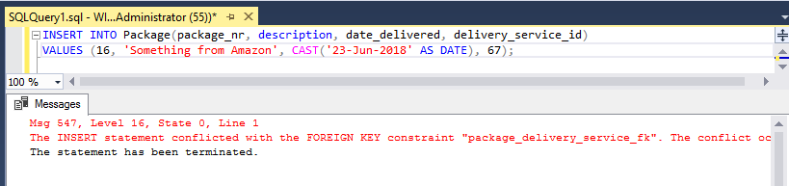

9. Diagnosis explanation

* 1. The insertion failed since the Package record cannot be created because of the fact that the “delivery_service_id” that is being passed in for the package does not match any existing “delivery_service_id” in the Delivery_service table. Essentially there is no delivery service with an id 67 in the Delivery_service table so the package insertion attempt fails.
  2. The error message can be interpreted by first looking at what “Line” number is throwing the error, in this case it’s Line 1 where the INSERT INTO command is. The next line states that “The INSERT statement conflicted with the FOREIGN KEY constraint...” so now we know that there is an issue with the INSERT command and the foreign key that is being used in that statement. The error also goes on to specify the database name, table, and specific column that is having the issue. So we can gather from all that information that the delivery_service_id we are attempting to use does not exist.

10. Join types explanation

When using a left outer join the results of the SQL query include records from the first table even if there happens to be no matching condition. It also returns all rows that match the join condition. A right outer join will return records from the second table, plus any records that match the join condition. The left and right outer joins are similar to one another, but they just return all records from different tables. A full outer join essentially combines both the left and right outer joins since it will returns all rows that match the join condition and also all rows from both tables that do not match the join condition. The inner join is the most restrictive because it will only return rows from both tables that match the join column condition specified in the query.

12. First SQL query

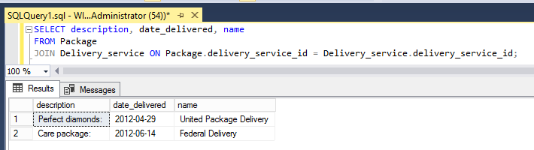

13. Missing row explanation

In the Delivery_service table there is a record with a name of “Dynamic Duo Delivery” which was not returned as part of the inner join because it did not have its delivery_service_id listed in the Package table. Also in the Package table there is a row with a “description” column that has a value of “French wine” which also was not returned in the query because the delivery_service_id is set to NULL which caused the row not to be returned as part of the join since it could not be found in the other table.

15. Second SQL query

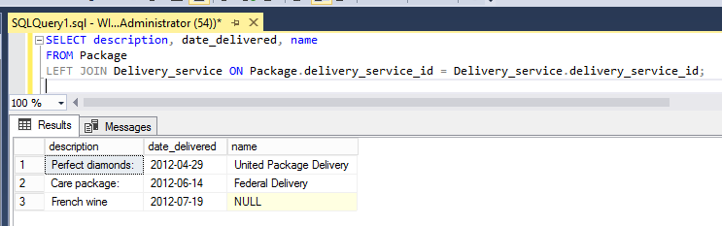

17. Third SQL query

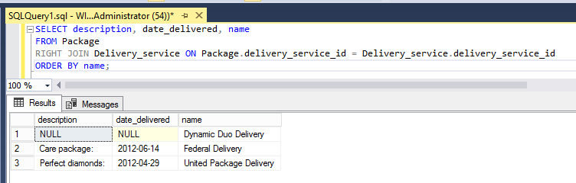

19. Fourth SQL query

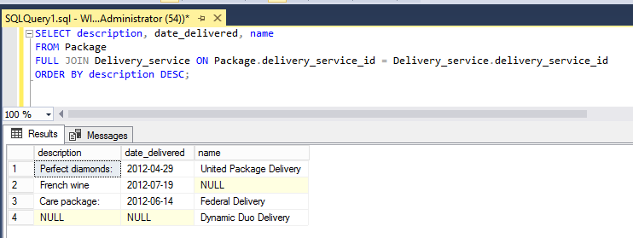



Your lab submission will be evaluated according to the following rubric.

|  |  |  |
| --- | --- | --- |
|  | **Letter Grade** | **Qualities Demonstrated by the Lab Submission** |
| **Correctness, completeness, and constitution**  **Measures the correctness and completeness of the results, and the quality of the constitution of the SQL constructs** | A+ ➔ 100 | The results and explanations are entirely complete and correct for all steps. There are absolutely no technical or other errors present. There is no known way to improve the logic and makeup of any of the SQL constructs. |
| A ➔ 96 | One insignificant technical or other error is present, but otherwise the results and explanations are entirely complete and correct for all steps. Excluding the insignificant error, there is no known way to improve the makeup of any of the SQL constructs. |
| A- ➔ 92 | One or two consequential technical or other errors are present, but otherwise the results and explanations are entirely complete and correct for all steps. Excluding the one or two errors, there is no known way to improve the makeup of any of the SQL constructs. |
| B+ ➔ 88 | A few steps have significantly incomplete or incorrect results or explanations. The results and explanations are complete and correct for the remainder of the steps. The logic and makeup of most SQL constructs are sound. |
| B ➔ 85 | A few steps have significantly incomplete or incorrect results or explanations. The results and explanations are mostly complete and correct for the remainder of the steps, with the exception of a few insignificant technical or other errors. The logic and makeup of most SQL constructs are sound. |
| B- ➔ 82 | About ¼ of the steps have significantly incomplete or incorrect results or explanations. The results and explanations are complete and correct for the remainder of the steps. The logic and makeup of at least ¾ of the SQL constructs are sound. |
| C+ ➔ 78 | About ¼ of the steps have significantly incomplete or incorrect results or explanations. The results and explanations are mostly complete and correct for the remainder of the steps, with the exception of a few insignificant technical or other errors. The logic and makeup of at least ¾ of the SQL constructs are sound. |
| C ➔ 75 | About half of the steps have significantly incomplete or incorrect results or explanations. The results and explanations are complete and correct for the remainder of the steps. The logic and makeup of at least half of the SQL constructs are sound. |
| C- ➔ 72 | About half of the steps have significantly incomplete or incorrect results or explanations. The results and explanations are mostly complete and correct for the remainder of the steps, with the exception of a few insignificant technical or other errors. The logic and makeup of at least half of the SQL constructs are sound. |
| D ➔ 67 | About ¾ of the steps have significantly incomplete or incorrect results or explanations. The results and explanations are complete and correct for the remainder of the steps. The logic and makeup of at least ¼ of the SQL constructs are sound |
| F ➔ 0 | All or almost all of the steps have incomplete or incorrect results or explanations. The logic and makeup of all or almost all of the SQL constructs are unsound. |